## horizontal line

Technical design HPC cluster *Gearshift*

2017-10-26 • hpc-3.0-beta

**─**

# 1 Summary

The Gearshift-cluster will be GCC's new research-cluster, to be operational in the second half of 2017. In design, technology, tooling and administration it will form the blueprint for future GCC HPC-clusters. The cluster will be using Openstack Ocata cloud-technology for its main components: compute, networking, authentication and local storage, and DELL/EMC Isilon storage for shared-storage purposes. Deployment of its components will be done by Ansible-playbooks, and Openstack-services will be run in Docker-containers.

# 2 Goals

- Robustness: The cluster is characterized by the atomized build of its components. This makes underlying hardware-components easily replacable, with built-in redundancy for the main-services.

- Flexibility: The computecluster itself is a virtual cluster. Through the use of Ansible-playbooks it is possible to replace and roll out new clusters when needed on the same hardware. These playbooks can be predefined, or created when needed.

- Portable: using Ansible-playbooks in combination with Docker-containers for running Openstack-services makes it possible to build new clusters virtually independent of underlying hardware.

- Independent: virtually all cluster-components are housed within the cluster itself.

# 3 Technical design

## a. Hardware inventory

The cluster contains the following hardware-components:

- 12 x Dell Poweredge R630, with 2 1TB SAS, and 1 3.2TB NVMe

- 4 x Dell/EMC Isilon X410 – 136T

- 1 x Mellanox Infiniband 18-ports switch

- 1 x Dell Networking S3048-ON 48-ports 1Gb-switch

- 1 x Dell Networking S6000-ON 32-ports 40Gb-switch

b. Global design

The cluster consists of 12 servers and 4 storage units, connected to 2 network-switches, and 1 interconnect-switch for the storage-units. The base-OS for the servers will be Ubuntu 16.04 LTS, with Openstack Ocata as the platform of choice for running all full VM's. All VM's in the cluster will run Centos 7.3. The Openstack Services will each run in a separate Docker-container, also based on Ubuntu 16.04.

Figure 1. Global design Gearshift-cluster

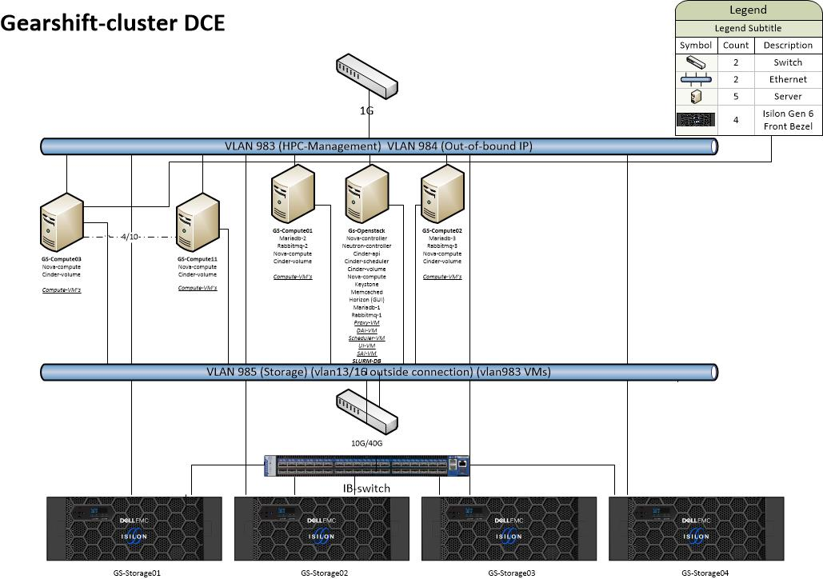

c. Openstack-design

All Openstack-services run in separate Docker-containers. The GS-Openstack-node is the controller-node for all essential Openstack-services: Nova-controller, Neutron-controller, Keystone (authentication) and Horizon (GUI). The Openstack-infrastructure will rely on a RabbitMQ-cluster as the messaging-service for communication within a Openstack-service. This cluster will contain 3 nodes, 1 on the GS-Openstack-node, and 1 on GS-compute01 and GS-compute02. The entire Openstack-configuration will use a MariaDB Galeracluster with 3 clustermembers. These will be the GS-Openstack-node, GS-compute01 and GS-compute02.

The GS-computenodes will furthermore contain 2 additional Openstack-services in a dockercontainer: Nova-compute and Cinder-volume.

Cinder-volume will be providing the /local mount on all Compute VM's.

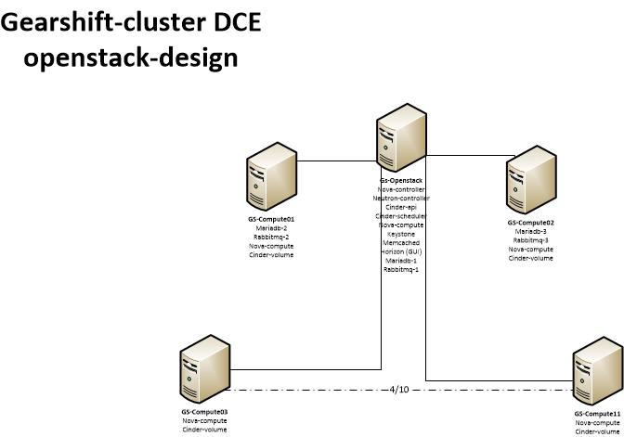Figure 2. Openstack-design

d. Network-design

The cluster will be connected to 4 separate networks: 1 for external connections (VLAN 13), 1 for management and cluster-communication (VLAN 983), 1 for Out-of-band communication with Idracs/IPMI's (VLAN984) and 1 for communication with storage-arrays (VLAN985). External connection will be a dedicated 10Gbit line, connecting the proxy-VM (airlock.hpc.rug.nl) to the rest of the cluster and its components. The management network will be a 1Gbit network, and all storage-traffic will be on a 10Gbit-network. The out-of-band network is 1Gbit.

The clusternetwork will be served by Openstack Neutron, and will contain 3 networks. These networks will be created over Linux-bridges on the Openstack-hypervisors. The GS-Openstack-node (controller-node) will have 2 bridges. 1 will serve a 10G network for outside connections, the other will serve 2 networks (VLANs 983/985) for management and storage (Figure 3). The GS-computenodes will have 1 bridge, for management and storage (VLAN983/985). These networks will be tunneled to the VM's (Figure 4). The Compute-VM's will have 2 networks, management/clustercommunication and storage. QoS (Quality of Service) will be configured to ensure minimum bandwith to the storage network (figure 5).

Figure 3. Network-design GS-openstack (controller-node)

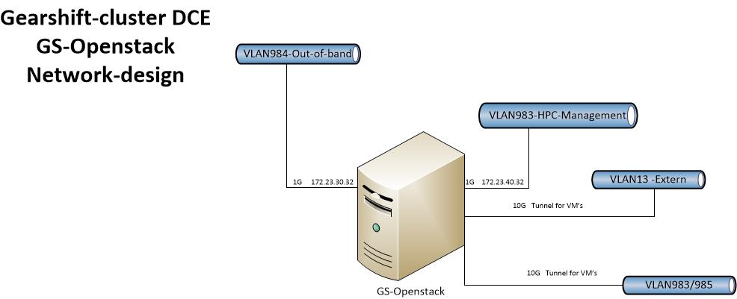

Figure 4. Network-design GS-computenode

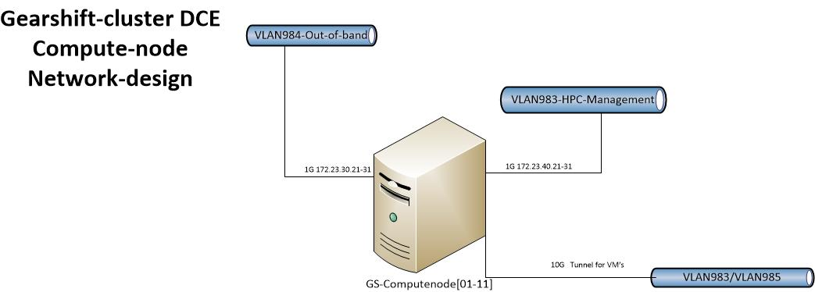

Figure 5. Network design clusternode (VM)

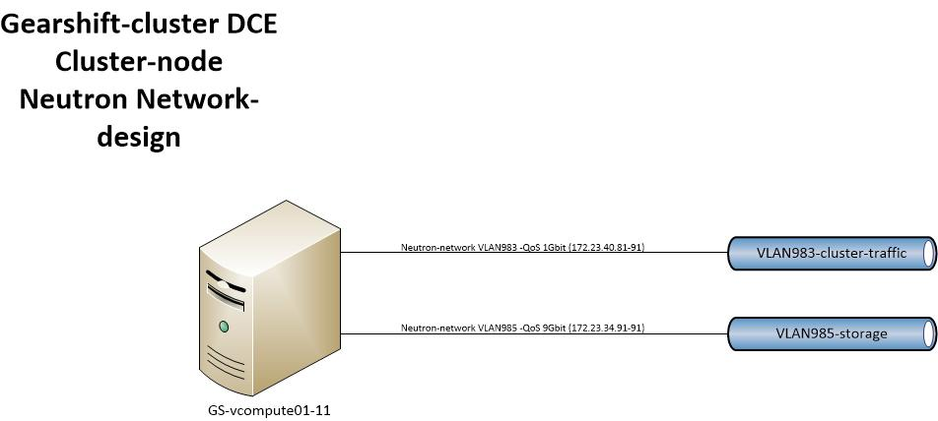

e. Compute-cluster-design

The compute-cluster will contain 11 compute-VM's, based on Centos 7.3, which will have access two local storage, and 2 storage-arrays (figure 6). The /apps, /tmp and /home filesystems will be served by the Isilon-storage array in Datacentre Eemspoort. The /prm storage will be served from the central research-data storagefacilities in Datacentre DUO.

All access to the compute-cluster, internal and external connections, will take place via the proxy-node, airlock.hpc.rug.nl (Figure 6). The proxy-node connects the rest of the cluster.

Scheduling for the cluster will be done by a dockerized Slurm-instance, hosted on the GS-controller.

Figure 6. Compute-cluster-design

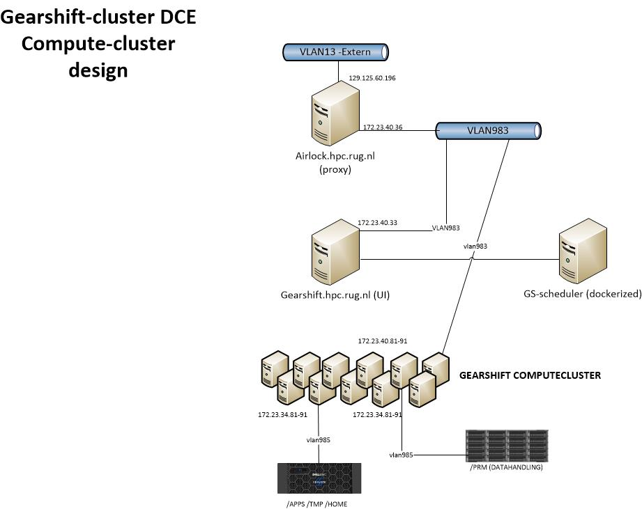

f. Administration/management design

The cluster houses several VM's for the administration of the cluster, and the software the cluster uses for its operations. These VM's are created on the Openstack-controller-node (GS-Openstack), and are based on Centos7.3 (figure 7).

- airlock.hpc.rug.nl. Proxy-node, steppingstone for access to the entire cluster

- gearshift.hpc.rug.nl. User-interface for cluster-operations (job-submitting etc.)

- imperator.hpc.rug.nl. Sys Admin Interface (SAI), for monitoring quota reports, slurm usage reports and various cron-jobs. Login for sysadmins

- sugarsnax.hpc.rug.nl. Deplay Admin Interface (Dai). Build-VM for software and modules. Login for deploy-admins.

Figure 7

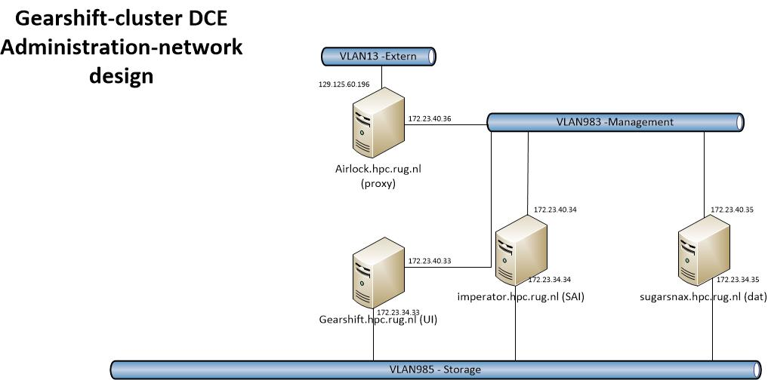

g. Tooling

Git repository

All tooling used to create the openstack cluster and the virtual compute cluster is available from the *gearshift* git repository. This repository is hosted at *git.webhosting.rug.nl* A local checkout of this repository is sufficient to roll out a new cluster during this process, a password (ansible vault) will be generated with which all passwords used will be encrypted. This password is not stored in the repository. Deployment commands are documented in the *README.md* of the gearshift repository.

Ansible

The ansible playbooks in this repository use ansible roles from the hpc-cloud repository. The roles are imported here explicitely by ansible using ansible galaxy. The roles install various docker images built and hosted by RuG webhosting. The docker images are built by jenkins from separate git repositories on [*https://git.webhosting.rug.nl*](https://git.webhosting.rug.nl/) and uploaded to the docker reposotory.

Monitoring

Both the HPC cluster and the openstack cluster on which the HPC cluster is installed will be monitored. Resource usage and performance characteristics of the dockerized openstack components will be reported to an externally running prometheus server using the cadviser tool. The prometheus server will also monitor various metrics of the physical host using the node_exporter tool. These metrics will be visiualized using grafana. Grafana will run on the same vm as the prometheus server. Both grafana and prometheus server will run inside docker containers on this vm.

The virtual HPC cluster will be monitored using ganglia. Ganglia will run on an external virtual machine as well.

The compute nodes of the virtual HPC cluster will be installed using packages from the *spacewalk.hpc.rug.nl* server. Since this server is only needed during instalation and upgrades of the compute cluster, it is not redundant. An ansible playbook is available in the *hpc/spacewalk* repository on *git.webhosting.rug.nl.* With this playbook it is possible to build a new spacewalk server within 15 minutes.

DNS

All DNS entries (both internal and external) that are needed for gearshift are placed in the rug.nl dns.

Monitoring

to be discussed/determined

h. Storage Design

- to be discussed/determined

# 4 Security

# Several measures are in place to ensure security for hardware and sofware in the entire infrastructure:

# - The hardware-infrastructure is housed in an UMCG-datacentre. Access is only possible through an official procedure. There are several access-codes in place (room, enclosures).

# - All access is done for cluster-purposes is done via a proxy-machine. This machine will be secured with an ip-tables type firewall, limiting tcp/ip ports and ip-spaces.

# - Network separation will be established via private vlans.

# - Openstack-security will be implemented, limiting TCP/IP-ports on a need-only basis to the underlying VM's.

# - Dockerized Openstack-services will be deployed via Ansible-playbooks. All security-keys and password (Openstack-accounts, database accounts etc.) related to Openstack will be stored by an encrypted and password-protected Ansible-vault.

# - Access to the Openstack-infrastructure will be handled by Keystone, both for authentication and authorization.